Software Requirements Specification

On

Product Management System



-Sumeet Bhati

-Srinivas Jadala

-Mounika Samudrala

-Chandu Kumar

-Abhiraj Bolleddu

-Abhishek Burre

TABLE OF CONTENTS

|  |  |
| --- | --- |
| 1. **INTRODUCTION**   1.1 Problem Statement | 3 |
| 1. **FUNCTIONAL REQUIREMENTS**   2.1 Registration  2.2 Login  2.3 Changes to cart  2.4 Payment  2.5 Logout  2.6 Report Generation | 4 |
| 1. **NON-FUNCTIONAL REQUIREMENTS**   3.1 Usability Requirements  3.2 Error Handling  3.3 Security Requirements  3.4 Software Requirements  3.5 Hardware Requirements | 5 |
| **4. USE CASE DIAGRAM** | 6 |
| **5. SEQUENCE DIAGRAM** | 7 |
| **6. USE CASE ANALYSIS** | 8 |
| **7. Entity Attributes** | 10 |
| **8. ER Diagram** | 11 |
| **9. Tables** | 12 |
|  |  |

**1. INTRODUCTION**

**1.1 Problem**

* This project aims to develop online shopping for customers with the goal that it is very easy to shop your loved things from an extensive number of online shopping sites available on the web.
* With the help of this you can carry out an online shopping from your home. Here is no compelling reason to go to the crowded stores or shopping centers during festival seasons.
* You simply require a PC or a laptop and one important payment sending option to shop online .To get to this online shopping system all the customers will need to have an email and password to login and proceed for shopping .
* The login credentials for an online shopping system are under high security and nobody will have the capacity to crack it easily. Upon successful login the customers can purchase a wide range of things such as mobiles, books, apparel, jewellery, infant care, gifts, tools, etc. can be dispatched using an online shopping system.
* And of course you will get your requested ordered items at your doorstep. It is simple. You will pick your favourite items from a variety of online shopping sites looking at cost and quality.
* No need to go physical shops with this you will have more time to spend with your family. It Just need a computer and a payment making options like net banking, credit card, debit card or paypal.

**2. FUNCTIONAL REQUIREMENTS**

**2.1 Registration**

* If a customer wants to buy the product then he/she must be registered, unregistered can’t go to the shopping cart.

**2.2 Login**

* Customers logins to the System by entering valid user id and password for shopping.

**2.3 Changes To Cart**

* Changes to the cart means customer after login or registration

Can make orders or cancel the product from the shopping cart.

**2.4 Payment**

* In this application we are dealing with the mode of payment by cash.

We will extend this to credit card, debit card etc in future.

**2.5 Logout**

* After ordering or surfing for the product customer has to logout.

**3. NON-FUNCTIONAL REQUIREMENTS**

**3.1 Usability Requirements**

* The user interface should be interactive, simple and easy to understand. The system should prompt for the user and administrator to login to the application for proper input criteria.

**3.2 Error Handling**

* Library management systems shall handle expected and unexpected errors in ways that prevent loss in information and long downtime periods.

**3.3 Security Requirements**

* The Library management system should provide databases modification only for the librarian after proper authorization. The system shall accommodate a high number of books and users without any fault.

**3.4 Software Requirements**

* Database - MSSQL is used as a database as it easy to maintain and retrieve records by simple queries which are in English language which are easy to understand and easy to write.
* Development tools and Programming language- Asp.NetMVC with C# programming, MSSQL DB, Bootstrap.

**3.5 Hardware Requirements**

* Intel core i5 and above is required for a stable experience and fast retrieval of data.
* 8 GB RAM is required as it will provide fast reading and writing capabilities which will in turn result in better performance time

1. **Use Case Diagram for Product Management System**

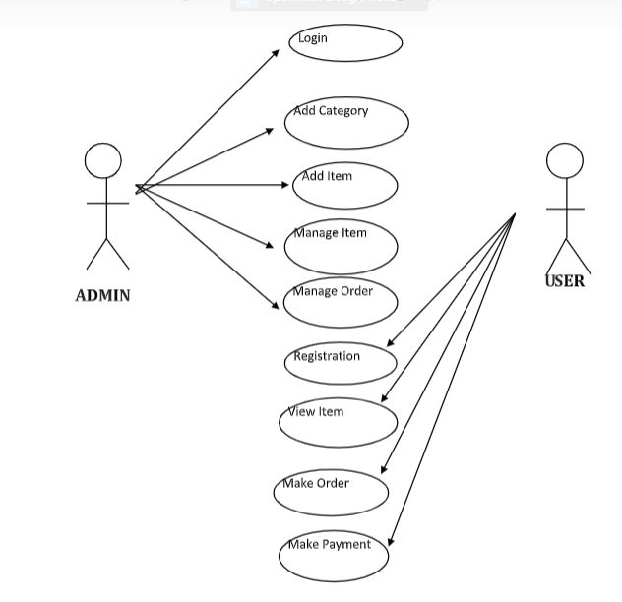

1. **Sequence Diagram for Product Management System**

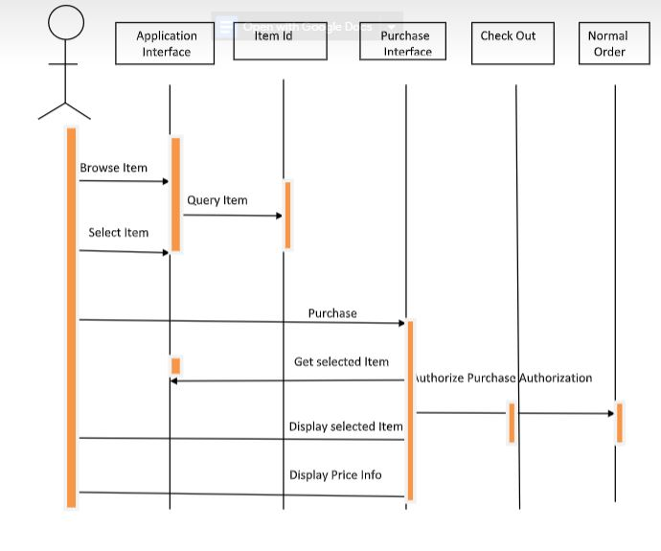

1. **Use Case Analysis**

|  |  |
| --- | --- |
| Name | Login |
| Actors | Admin/Users |
| Preconditions | Existence of database and correctly installed web server based server |
| Description | When program is opened using browser the user sees logon page |

|  |  |
| --- | --- |
| Name | Manage users |
| Actors | Admin |
| Preconditions | Existence of database and correctly installed web server based server |
| Description | Manage the users and their actions |

|  |  |
| --- | --- |
| Name | Add/Remove items to the list |
| Actors | Admin |
| Preconditions | Existence of database and correctly installed web server based server |
| Description | Manage the items in the list |

|  |  |
| --- | --- |
| Name | Processing issues |
| Actors | Admin |
| Preconditions | Existence of database and correctly installed web server based server |
| Description | Manage requests by users |

|  |  |
| --- | --- |
| Name | Select |
| Actors | User |
| Preconditions | Existence of database and correctly installed web server based server |
| Description | Select the item from list |

|  |  |
| --- | --- |
| Name | Buy |
| Actors | User |
| Preconditions | Existence of database and correctly installed web server based server |
| Description | Buy the selected item from list |
| Name | Payment |
| Actors | User |
| Preconditions | Existence of database and correctly installed web server based server |
| Description | Make the payment for selected item |

|  |  |
| --- | --- |
| Name | Cart |
| Actors | User |
| Preconditions | Existence of database and correctly installed web server based server |
| Description | Add the items in the cart |

1. Entity Attribute

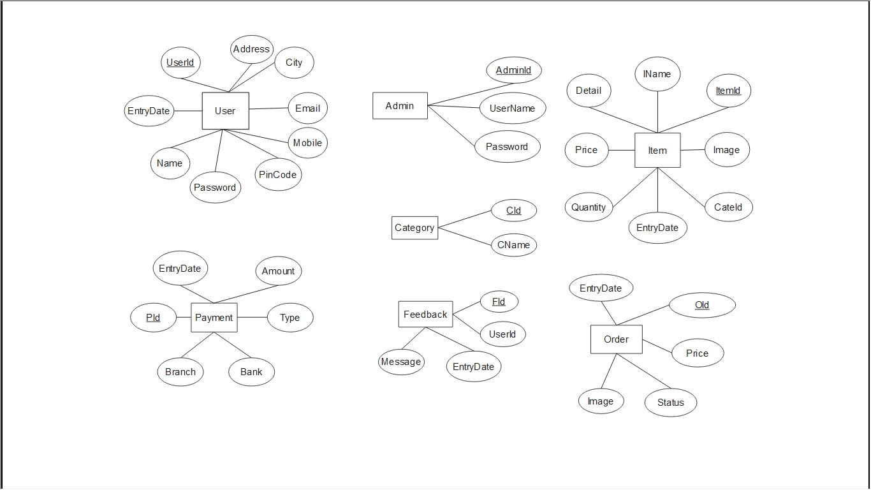

1. ER Diagram

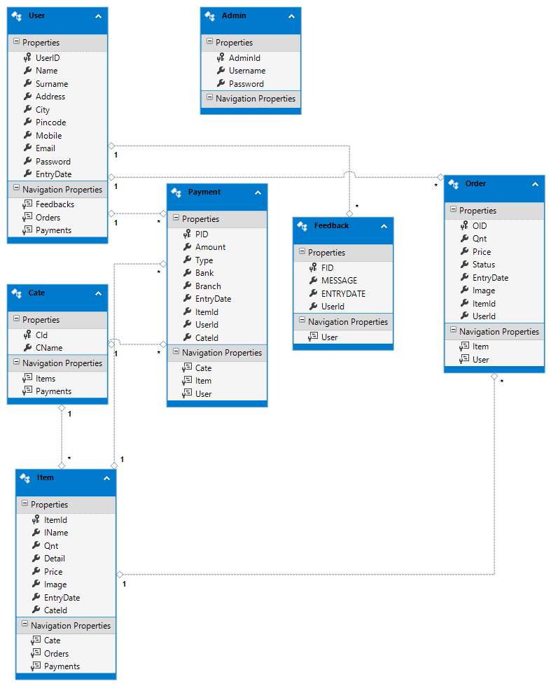

1. Tables

